

**National Institute of Technology, Calicut**

**Department of Electronics and Communication Engineering**

**EC3093D - Digital Signal Processing Lab**

Experiment No. 5: IIR Filter design (Tool – MATLAB)

Submitted by : Group A-03

Group Members

Adwayith K S B210664EC

Adhyuth Narayan B210650EC

Aditya Tuppad B210038EC

1. Write MATLAB codes for obtaining the

(i) parallel form realization and

(ii) cascade form realization

for the following transfer functions:

1. 𝐻(𝑧) = $\frac{0.4\left(1-z^{-1}\right)}{1+1.2z^{-1}+0.32z^{-2}}$
2. 𝐻(𝑧) = $\frac{z^{2} - 0.16}{z^{2} + 1.1 z + 0.18}$

Ans .

Cascade form answer for both a and b:

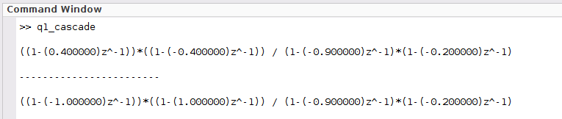

Parallel form answer for both a and b:

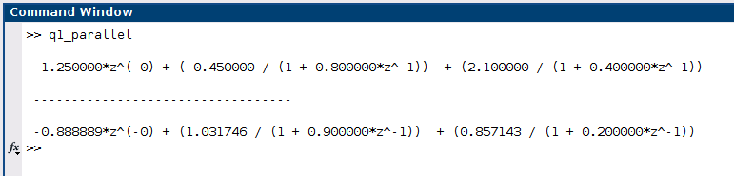

1. Given each of the following digital transfer functions,

(i) 𝐻(𝑧) = $\frac{0.35\left(1+z^{-1}\right)}{1-0.3z^{-1}}$

(ii) 𝐻(𝑧) = $\frac{0.1\left(1- z^{-1}\right)}{1 + 0.8 z^{-1}}$

(iii) 𝐻(𝑧) = $\frac{0.7\left(1+z^{-2}\right)}{1-1.26{ z}^{-1}+ 0.4 z - 2}$

(iv) 𝐻(𝑧) = $\frac{0.8\left(1 - 1.6z^{-1} + z^{-2}\right)}{1-0.28z^{-1} + 0.6 z^{-2}}$

(v) 𝐻(𝑧) = $\frac{0.5 +0.7 z^{-1} + z^{-2}}{1 + 0.7 z^{-1} + 0.5 z^{-2}}$

1. Plot the magnitude response and phase response for each transfer function.
2. Identify the corresponding filter type, such as lowpass, high-pass, bandpass, band-stop or all-pass.

i)

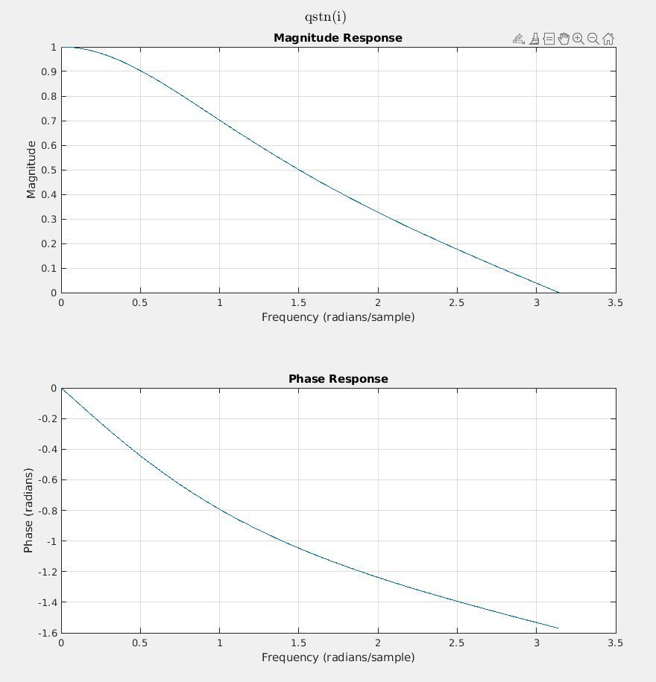

This is a low pass filter as it passes low frequencies and blocks high frequencies.

ii)

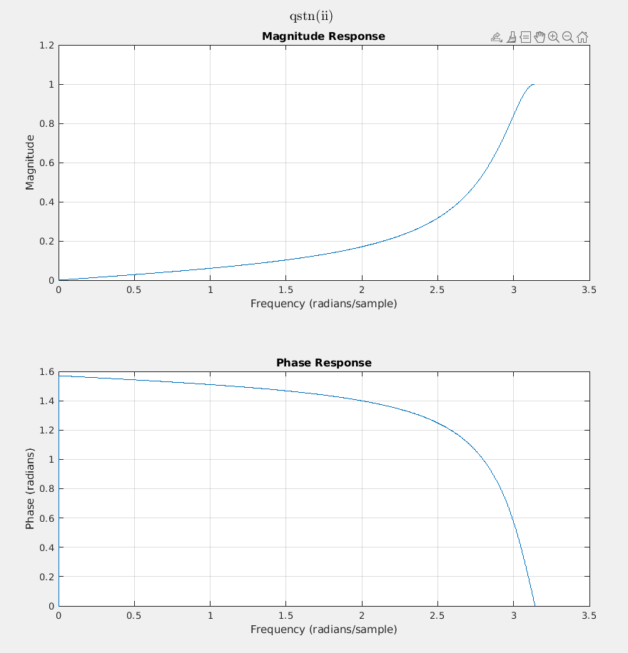

This is a high pass filter as it passes high frequencies and blocks low frequencies.

iii)

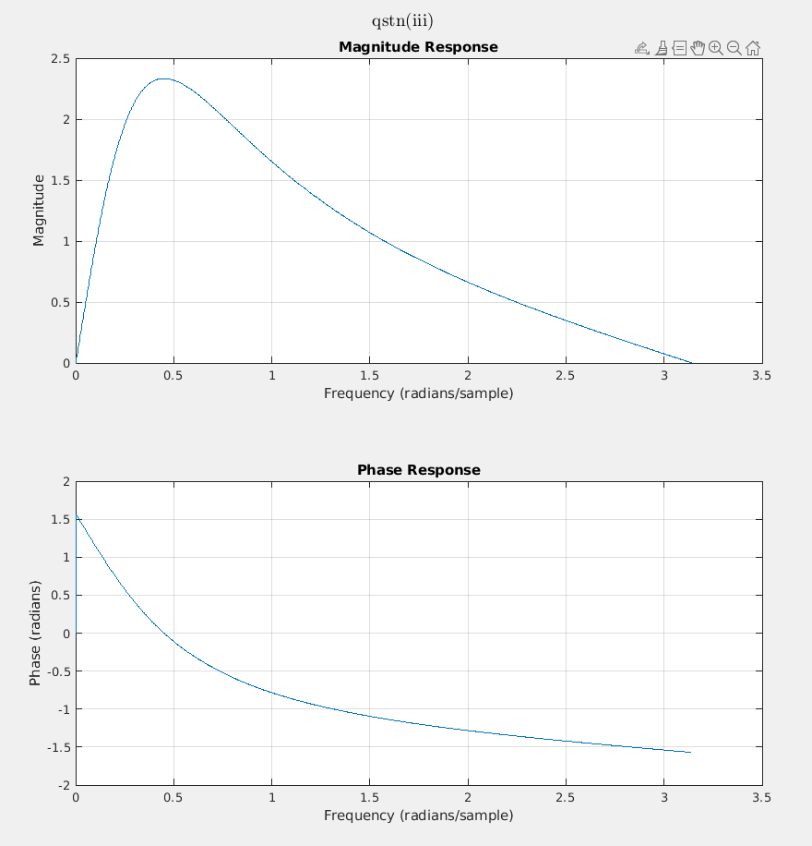

It is a bandpass filter, as only a band of frequencies are passed and the rest of low and high frequency bands are blocked.

iv)

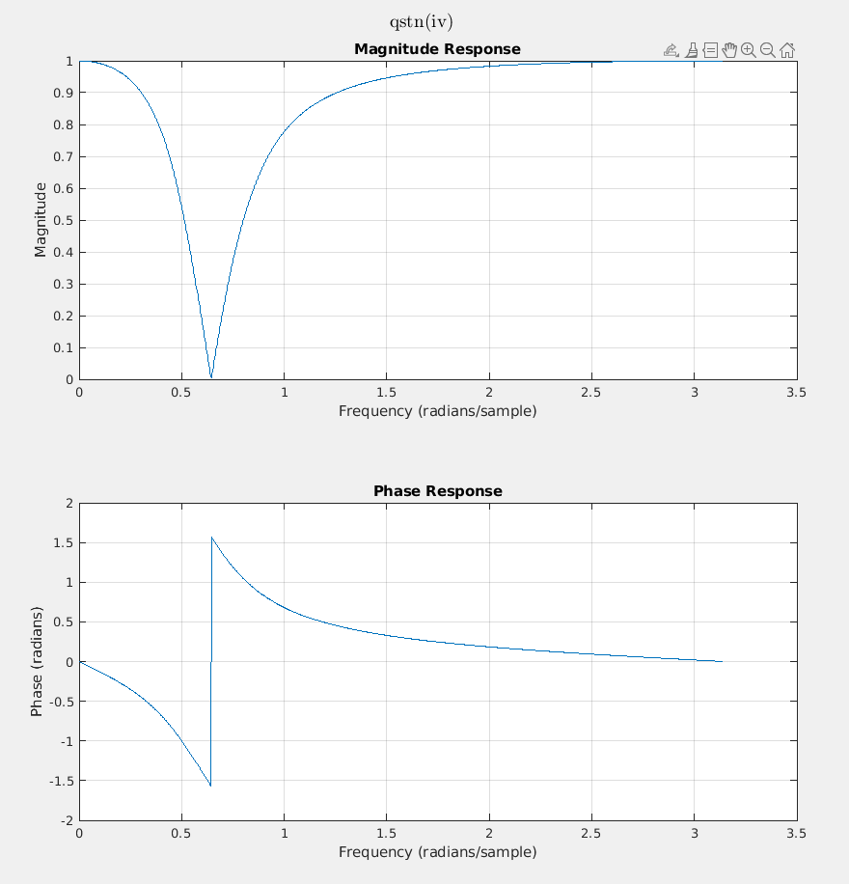

It is a band reject filter as only a small band of frequency is not passed and the rest of the frequencies are passed.

v)

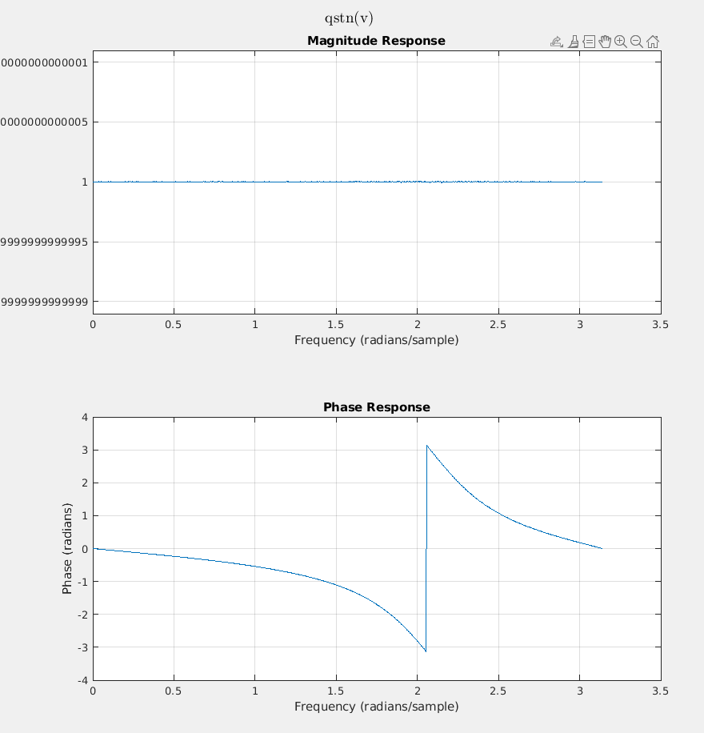

This is an all pass filter as all the frequencies are passed and none are stopped.

1. Given a lowpass prototype 𝐻𝑃(𝑠) = $\frac{1}{s+1}$, determine each of the following analog filters and plot their magnitude responses from 0 to 200 radians per second.

(i) The lowpass filter with a cutoff frequency of 40 radians per second.

(ii) The high-pass filter with a cutoff frequency of 40 radians per second.

(iii) The bandpass filter with a center frequency of 100 radians per second

and bandwidth of 20 radians per second.

(iv) The band-reject filter with a center frequency of 100 radians per second

and bandwidth of 20 radians per second.

Ans:

1. The lowpass filter can be formed by replacing ‘s‘ in prototype function with $\frac{s}{40}$.

Hence the required filter equation is $H\left(s\right)=\frac{40}{40+s}$

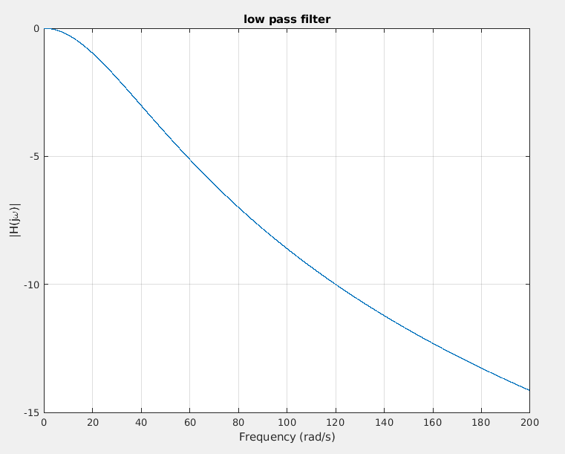

Here we can observe that the – 3db frequency occurs at 40 db therefore it matches the design constrains given in the question.

1. Here to obtain a high pass filter we should replace ‘s’ in prototype function with $\frac{40}{s}$.

The resulting filter equation is $H\left(s\right)=\frac{s}{s+40}$

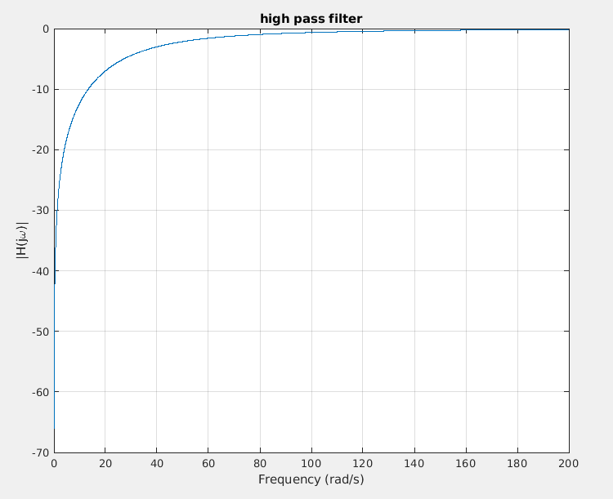

Here also the -3db point is at 40 db and therefore the output obtained is as per the designing constrains given in the question.

1. To obtain the band pass filter we should replace s by $\frac{s^{2} + wh*wl}{s*\left(wh - wl\right)}$

Where wh is upper cut off frequency and wl is lower cutoff frequency

Here the final equation that we get is $H\left(s\right)=\frac{20s}{s^{2}+20s+9900}$.

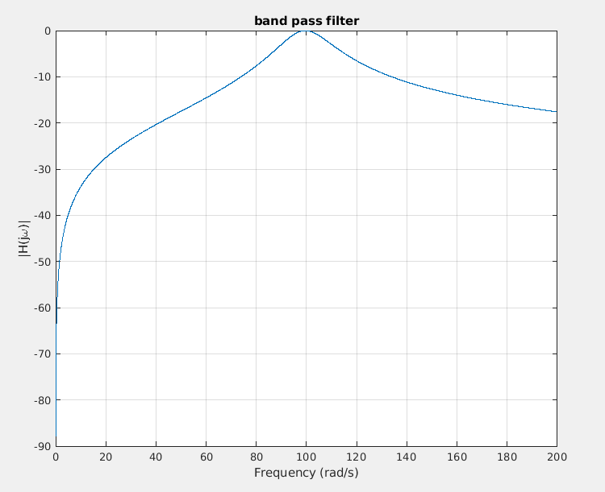

As per the designed filter:

Lower cutoff frequency = 90Hz

Upper cutoff frequency = 110Hz

Bandwidth = 20Hz

Centre frequency = 100Hz

Therefore, the design constrains given in the questions are all met.

1. To obtain the band-stop filter, we should replace ‘s’ by $\frac{s \left(wh-wl\right)}{s^{2}+wh*wl}$

The filter equation obtained here is $H\left(s\right)=\frac{s^{2}+9900}{s^{2}+20s+9900}$.

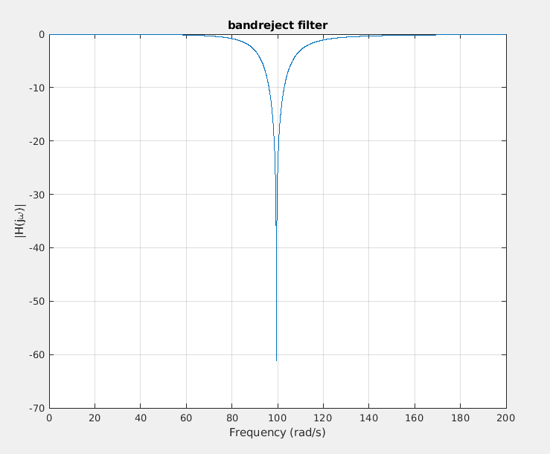

Lower cutoff frequency = 90Hz

Upper cutoff frequency = 110Hz

Centre frequency = 100Hz

Bandwidth = 20Hz

Here all the design constrains given in the question is met and the filter is designed successfully.

3. Given a lowpass prototype 𝐻𝑃(𝑠) = 1 𝑠+1, determine each of the following analog filters and plot their magnitude responses from 0 to 200 radians per second.

(i) The lowpass filter with a cutoff frequency of 40 radians per second.

(ii) The highpass filter with a cutoff frequency of 40 radians per second.

(iii) The bandpass filter with a center frequency of 100 radians per second

and bandwidth of 20 radians per second.

(iv) The bandreject filter with a center frequency of 100 radians per second

and bandwidth of 20 radians per second.

Ans:  
 (i)